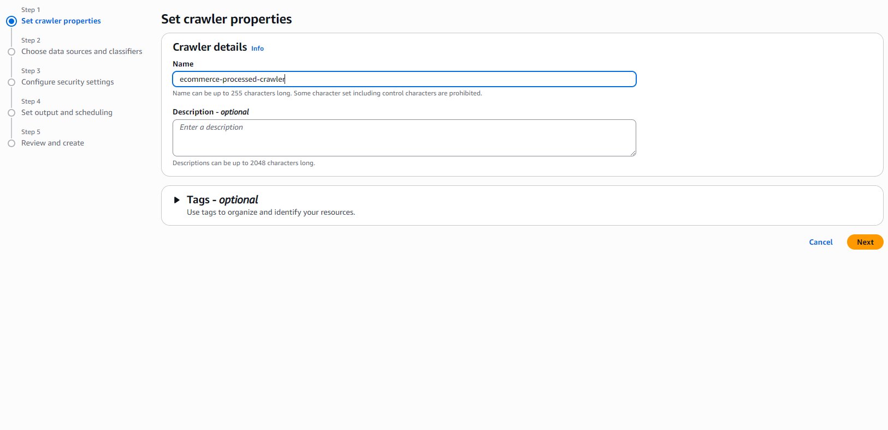
Step 1: Set crawler properties :

Choose data sources and classifiers :

-Not yet

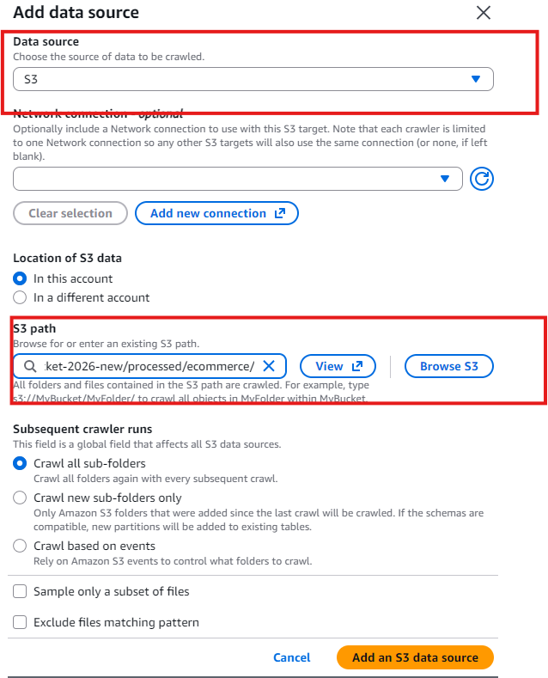

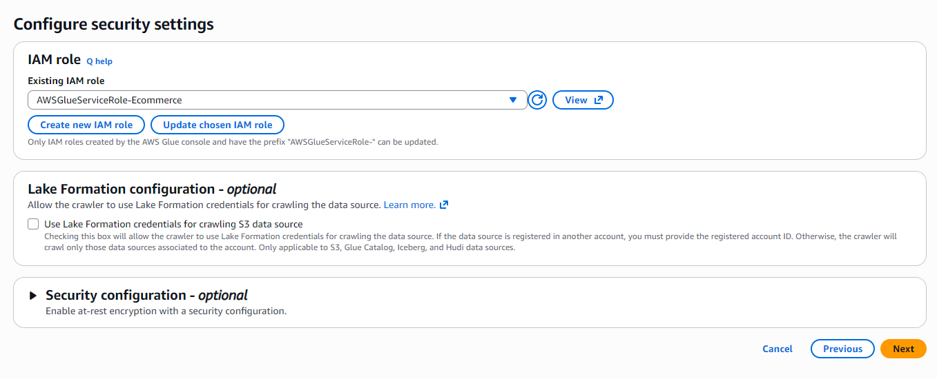
IAM role :

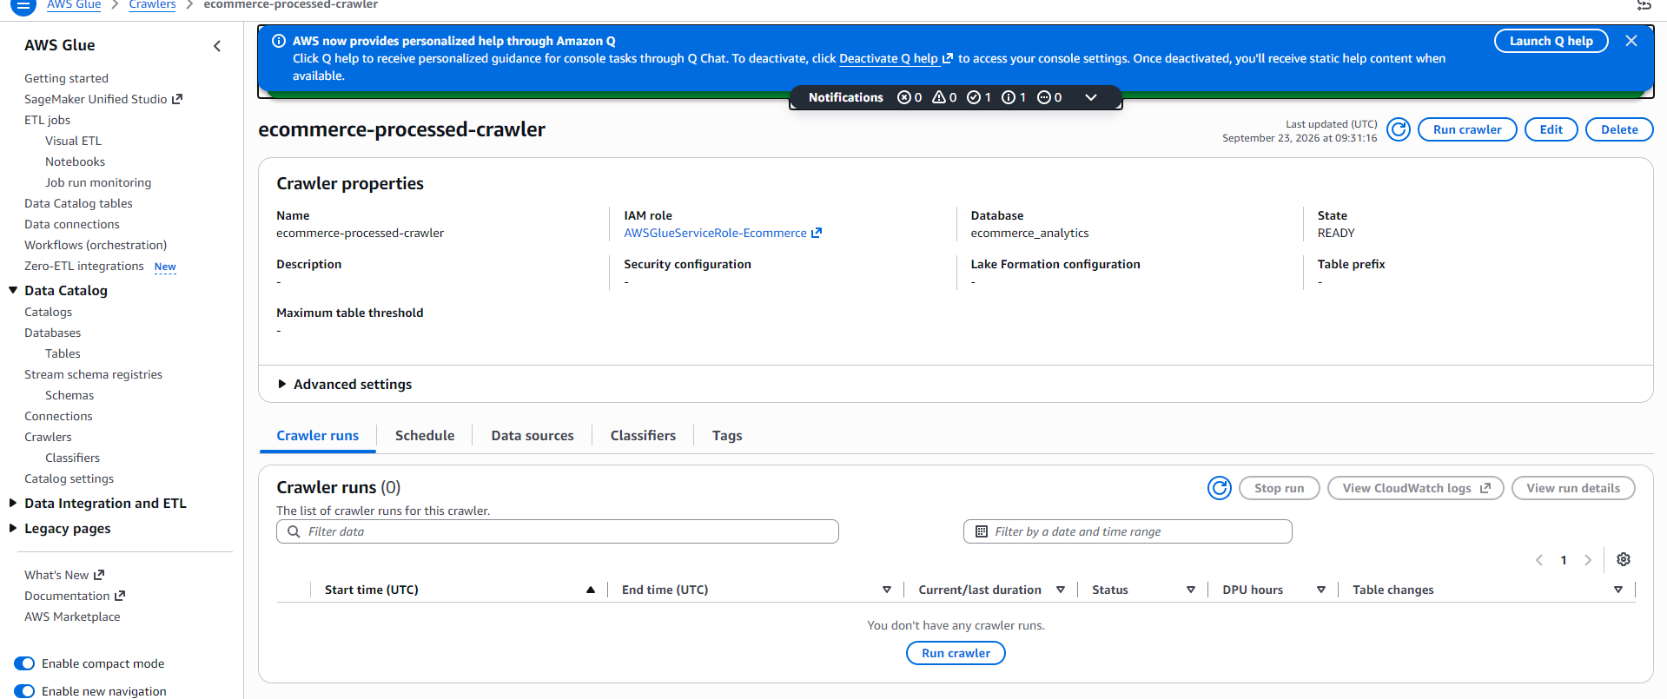
Target database :

Create DB and Choose in Edit Crawler :
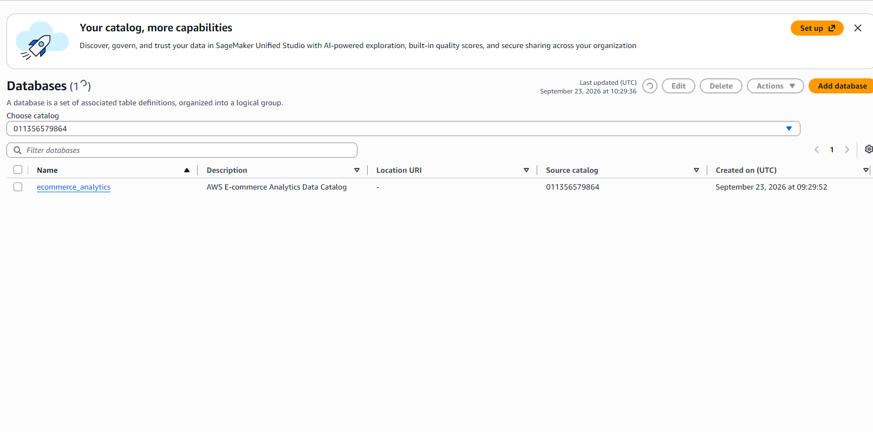

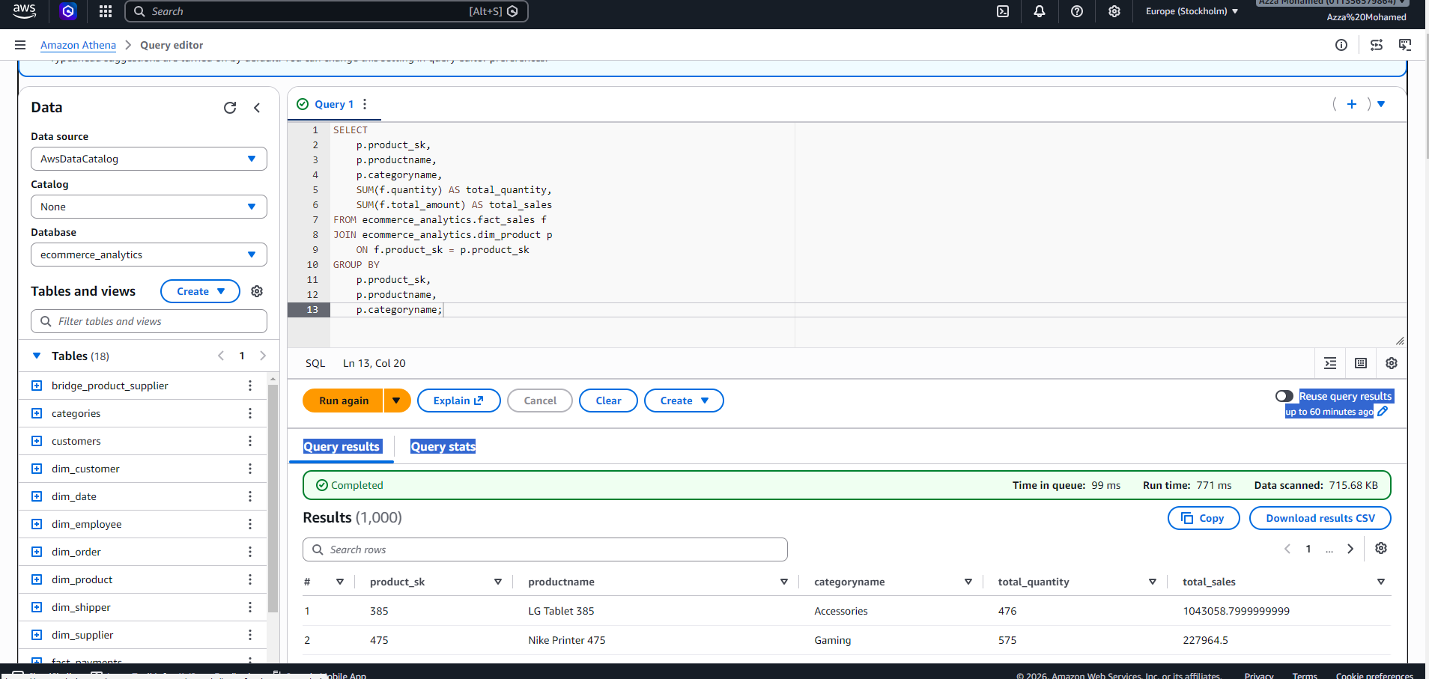
Athena Query Editor :

Gold Layer :
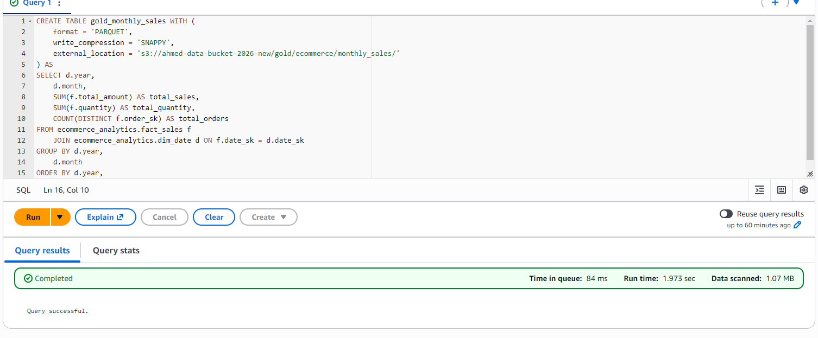
1-Monthly Sales

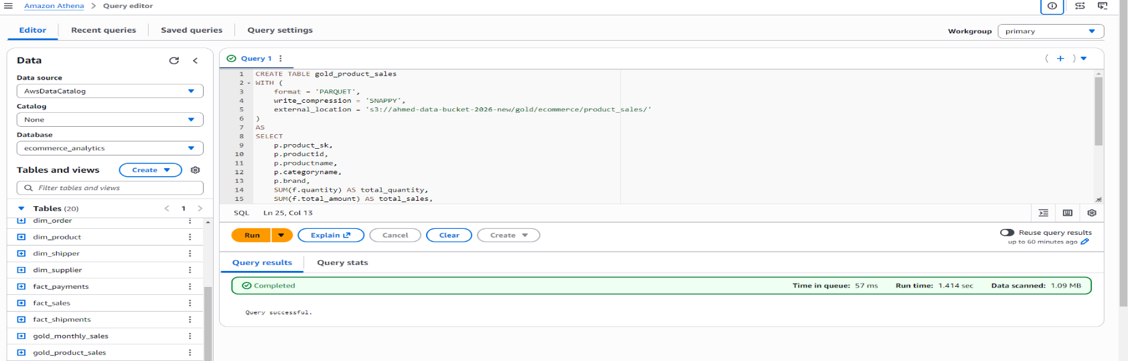
2-Product Sales

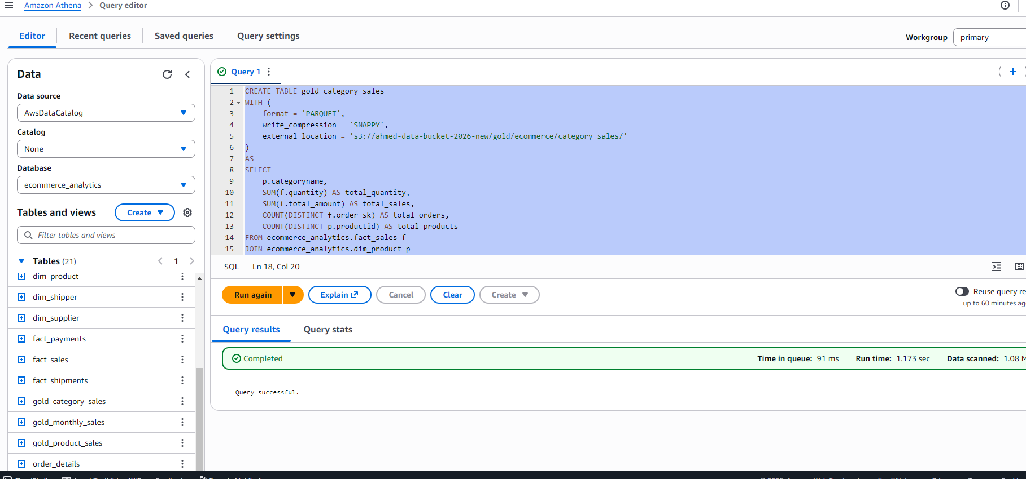
Category Sales :

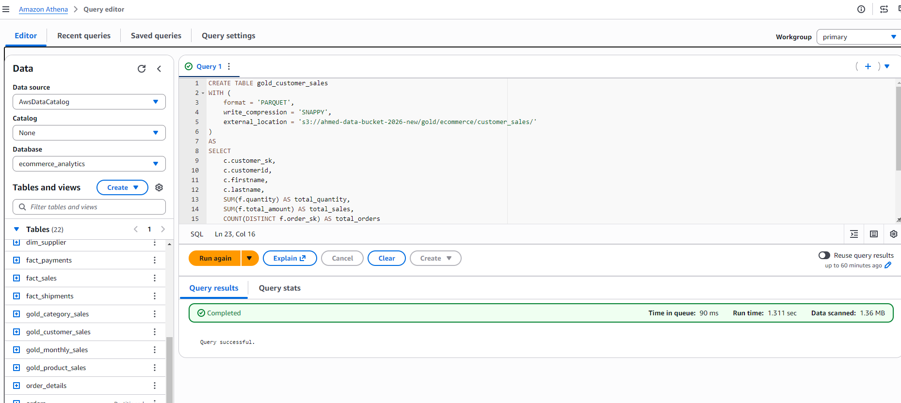
Gold Customer Sales

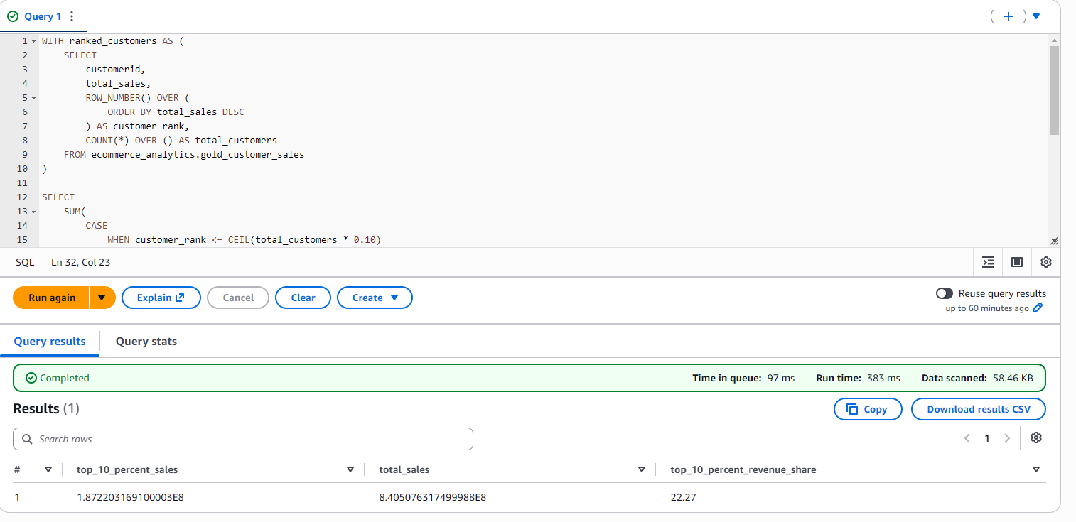
Customer Concentration :

Customer Revenue Concentration: The top 10% of customers generated 22.27% of total sales, while the remaining 90% contributed 77.73%, indicating that revenue is distributed across a broad customer base rather than being heavily concentrated among a small customer segment .

Month-over-Month (MoM) Growth. :
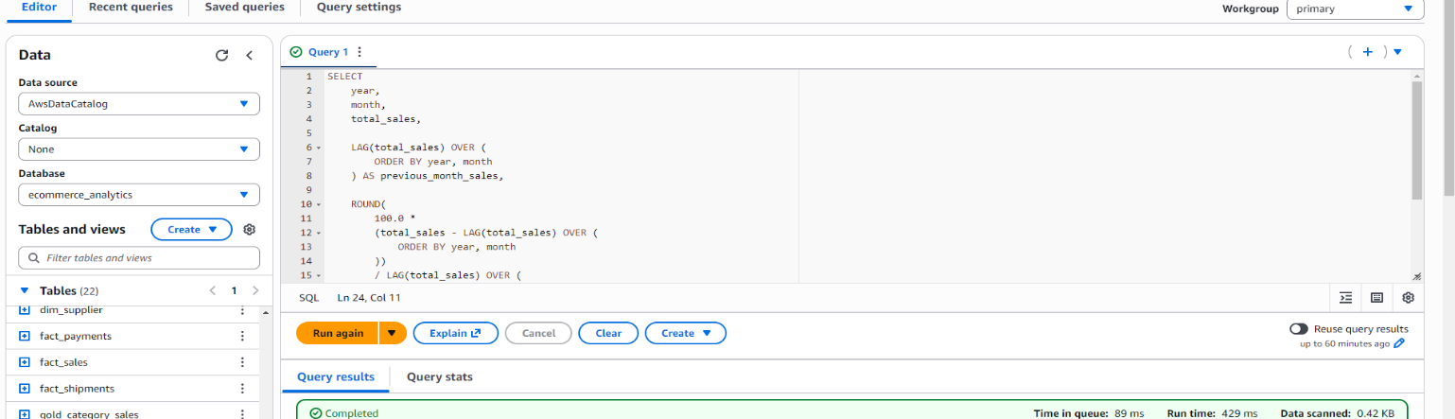

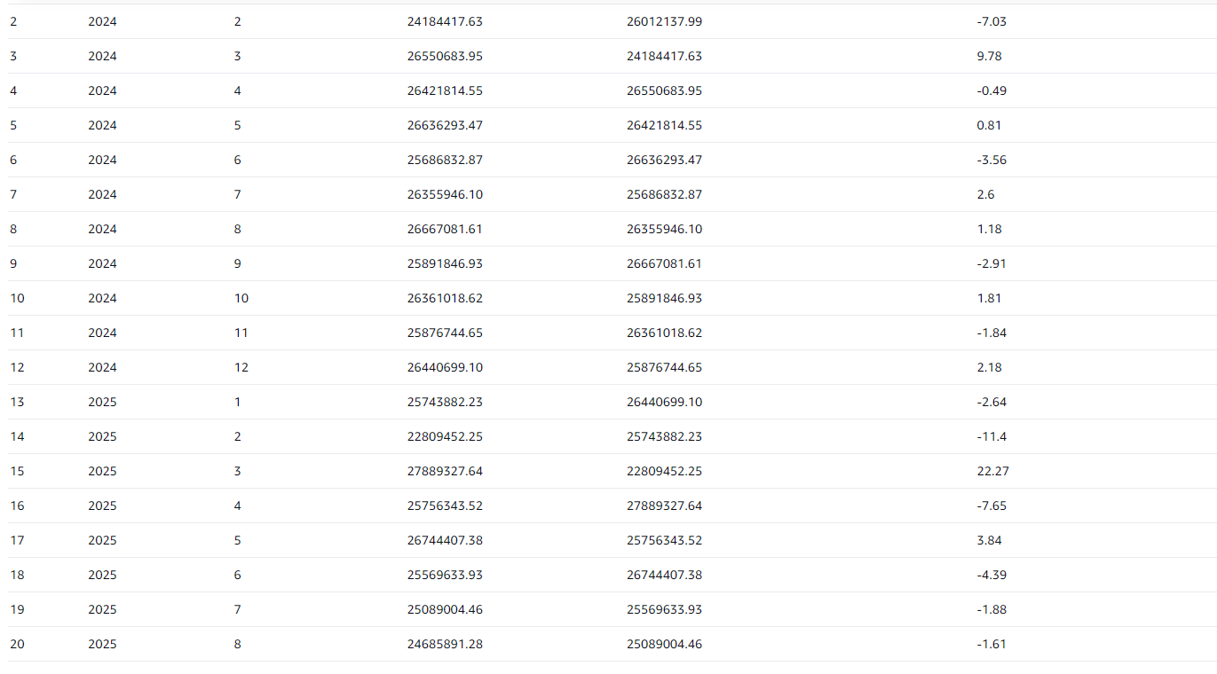
Sales showed noticeable month-to-month fluctuations, with the strongest growth in March 2025 (+22.27%).
The largest decline occurred in September 2026 (-53.75%), which should be validated to confirm that the month contains complete data.
Which product categories generate the largest share of revenue :
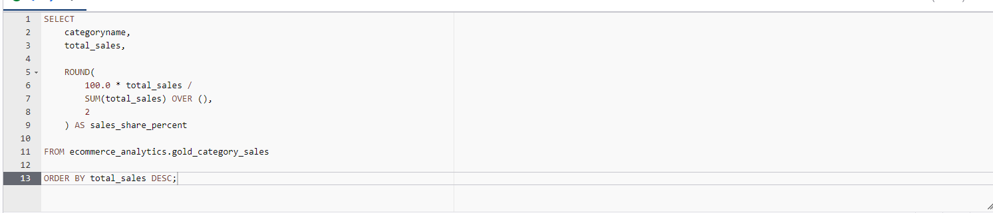

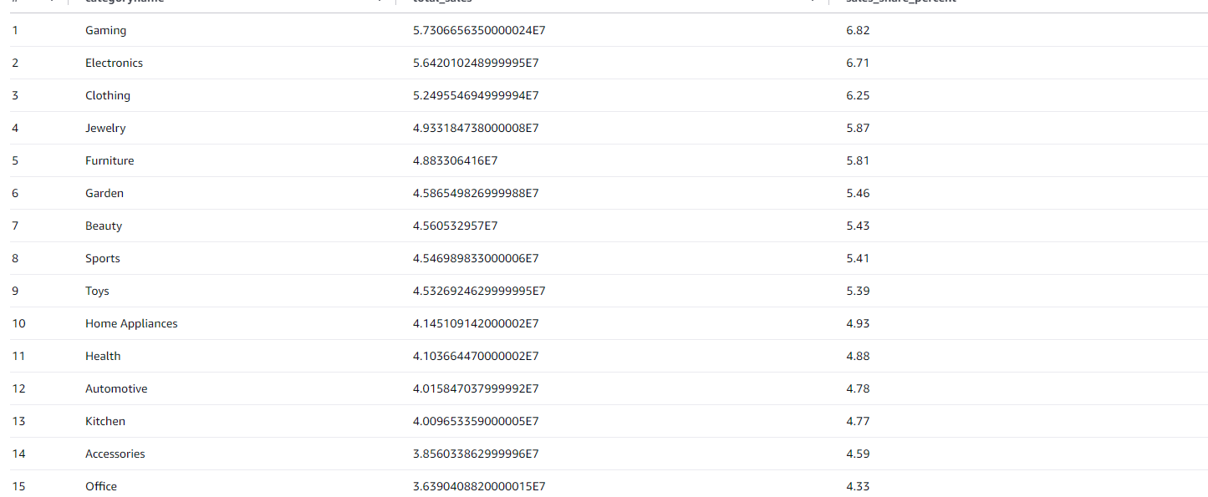
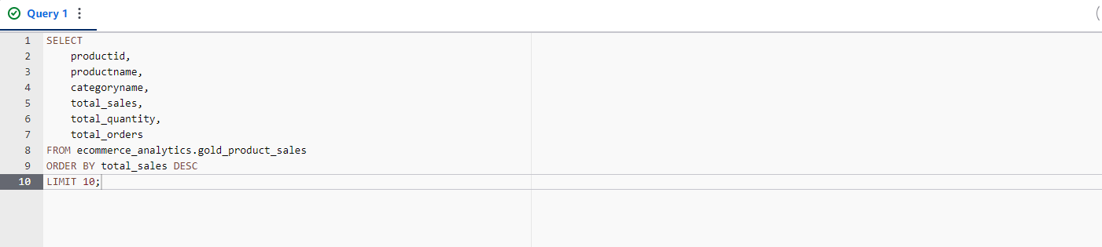
Top 10 Products by Sales :

